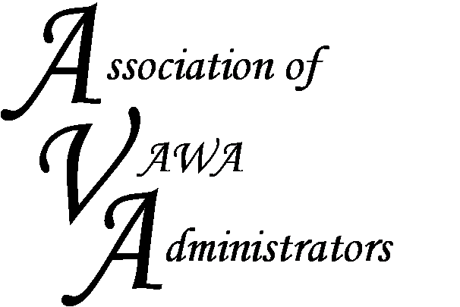

To encourage and facilitate mutual support, awareness and cooperation among
states and territories administering Violence Against Women Act formula grants.

Peer-to-Peer Meeting

Best Western PLUS Austin City Hotel

Austin, Texas
February 7-8, 2017

AGENDA

Tuesday, February 7, 2017

1:00 – 1:20 Welcome and Introductions

1:20 – 4:15 Financial Management Discussion
2:30 – 2:45 Break

- Tracking category percentages
- Funding strategies and meeting the statutory set-asides
- Carrying monies over year to year to fill in gaps in funding areas
- Managing returned monies

4:15 – 4:30 First Day Wrap-up and discuss tomorrow’s agenda

Wednesday, February 8, 2017

8:30 – 8:45 Welcome over Coffee

8:45 – 12:00 Programmatic Management Discussion
10:00 – 10:15 Break

- VAWA Implementation Planning
- Technical Assistance Providers: How do you access services?

12:00 – 1:15 Lunch and networking time

Austin Peer-to-Peer Meeting
Agenda

1:15 – 4:15 Programmatic Management Discussion (Cont.)
2:30 – 2:45 Break

- Reporting challenges: Including annual reports, close-out and red flag reports.
- Monitoring the challenging subgrantee program
- PREA and Discretionary Projects: What’s being funded?
- Indirect Costs
- AVA Website

4:15 to 4:30 Meeting Wrap-up

