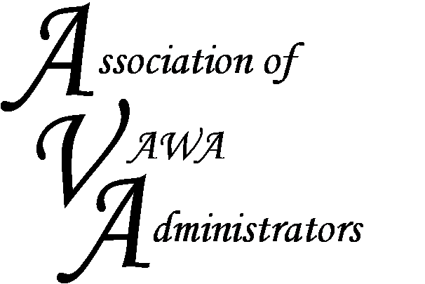

To encourage and facilitate mutual support, awareness and cooperation among
states and territories administering Violence Against Women Act formula grants.

Peer-to-Peer Regional Meeting

Best Western PLUS Austin City Hotel
2200 South Interstate 5
Austin TX 78704
February 7-8, 2017

REGISTRATION FORM

The STOP formula grant program is a complex program with numerous statutory mandates. This regional meeting will provide a networking opportunity for both new and seasoned administrators to learn from one another about the day-to-day management of their STOP funds. We will discuss challenges and share expertise involved in administering the STOP Formula Grant Program. This is intended to be an interactive discussion forum attended solely by STOP administrators and their staff. Registration is limited to the first 25 people.

Name(s) of Attendees:

State/Territory:

Contact Info:
Address:

Phone:

Email:

We will be sharing strategies and tools with one another. If you have a good system in place for tracking or monitoring your STOP awards (e.g. spreadsheets, monitoring questionnaire, etc.) and are willing to share, please forward those to Dorene Whitworth at Dorene@avadministrators.org in advance of the meeting.

Additional topics you may be interested in:

Please email this form to Dorene Whitworth at Dorene@avadministrators.org

