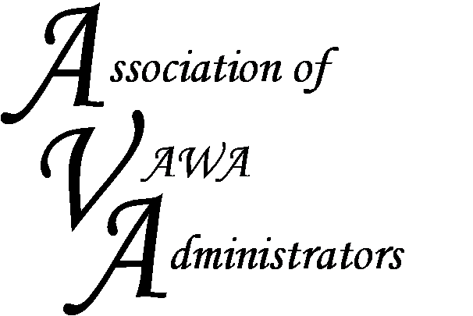

To encourage and facilitate mutual support, awareness and cooperation
among states and territories administering Violence Against Women Act grants.

Peer-to-Peer Regional Meeting

Homewood Suites by Hilton
706 Church Street
Nashville, TN 37203
October 4, 2017 - 8:30 am – 4:00 pm
October 5, 2017 - 8:00 am – 12:00 pm

REGISTRATION FORM

The STOP formula grant program is a complex program with numerous statutory mandates. This regional meeting will provide a networking opportunity for both new and seasoned administrators to learn from one another about the day-to-day management of their STOP funds. We will discuss challenges and share expertise involved in administering the STOP Formula Grant Program. This is intended to be an interactive discussion forum attended solely by STOP administrators and their staff.
Name(s) of Attendees:

State/Territory:

Contact Info:
Address:

Phone:

Email:

We will be sharing strategies and tools with one another. If you have a good system in place for tracking or monitoring your STOP awards (e.g. spreadsheets, monitoring questionnaire, etc.) and are willing to share, please forward those to Barry Bryant at Barry@avadministrators.org in advance of the meeting.

Additional topics you may be interested in:

Please email this form to Barry Bryant at Barry@avadministrators.org

