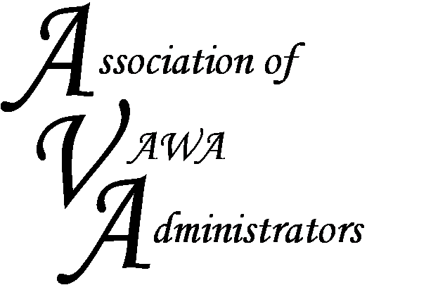

To encourage and facilitate mutual support, awareness and cooperation among
states and territories administering Violence Against Women Act formula grants.

Good morning VAWA Administrators!
We are very excited that you are planning on attending our Peer-to-Peer mentoring conference in Nashville in early October. The AVA Board is working to provide you with an assortment of networking opportunities that will best suit your greatest needs.
We will be staying at the Homewood Suites by Hilton located in Nashville, TN at 706 Church Street. Their contact number is (615) 742-5550.
We encourage you to arrive in Nashville on October 3rd. We will start our mentoring conference on Wednesday, October 4th at 8:30 am and continue until around 4 pm that day. On Thursday, we will start at 8 am and end by midday to accommodate early travel back to your home state.

We are building an agenda that is based in part on feedback from your fellow administrators who attended past peer-to-peer mentoring conferences. We want to include hands-on discussion topics that seem to be of the greatest interest to you, including:

- The Muskie Report – we will log into these reports and veteran administrators will guide you through the report
- Implementation Plans – we will bring several sample Implementation Plans and review thoroughly with hopes of helping you with completing future IP’s.
- Table Topics – we would like to have open discussion that is useful to everyone. In advance of the meeting, please complete the Registration Form and share with me any other issues that you would like to discuss.

Over the next few weeks, please let me know how to make this experience better for you. Feel free to call me at (919) 588-9615 or you can always email me at barry@avadministrators.org
I can’t wait to meet you in Nashville and I am looking forward to working with each of you soon!

Barry

