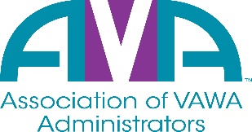

To encourage and facilitate mutual support, awareness and cooperation
among states and territories administering Violence Against Women Act grants.

Election Questionnaire

Name of Candidate:

Title/Position of Candidate:

State Total number of years as a VAWA Administrator/staff:

Contact information, if available:

State:

Agency:

Phone Number:

Email address:

Please answer the questions below to provide information about your qualifications to other VAWA Administrators.
1. Briefly describe current VAWA responsibilities.

2. Briefly describe other relevant experience or qualifications.

3. Brief statement of why you wish to be on the AVA Board of Directors.

By checking this box, I declare my intention to be a candidate for the AVA Board of Directors and signify my agency is or will become an active member of AVA.

