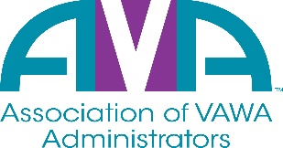

To encourage and facilitate mutual support, awareness and cooperation
among states and territories administering Violence Against Women Act grants.

2022 Election Questionnaire

Name of Candidate: Shataun Hailey

Title/Position of Candidate: Vice President

State Total number of years as a VAWA Administrator/staff: 6 years

Contact information:

State: IL
Agency: Illinois Criminal Justice Information Authority
Phone Number: 312-814-8100
Email address: Shataun.Hailey@Illinois.gov

Please answer the questions below to provide information about your qualifications to other VAWA Administrators.
1. Briefly describe current VAWA responsibilities.
In my current role as the VAWA Administrator, I provide overall coordination and administration of the VAWA awards and programs. In this role, I develop and coordinate policies and programs related to the implementation of VAWA. I also oversee the subrecipients of the award to ensure compliance with federal requirements, implementation and plan goals.

2. Briefly describe other relevant experience or qualifications.
I have been in the role of VAWA Administrator for six years now including serving on the AVA Board for three years. I have also managed other federal awards and am familiar with the federal requirements and expectations.

3. Brief statement of why you wish to be on the AVA Board of Directors.
I would like to continue to hold my seat on the AVA Board of Directors as the opportunity allows me to network and collaborate with other VAWA administrators from other states. I also enjoy discussing and working through some of the challenges we face together as a team.

By checking this box, I declare my intention to be a candidate for the AVA Board of Directors and signify my agency is or will become an active member of AVA.

