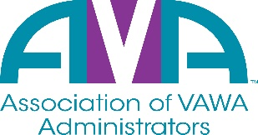

To encourage and facilitate mutual support, awareness and cooperation among
states and territories administering Violence Against Women Act formula grants.

SAVE THE DATE – May 10th, 2022
AVA Annual Meeting – 1:30pm – 3:00pm EST
AVA’s Annual Meeting will take place this year, via webinar. Please join us as we provide:
- Updates and opening remarks from AVA’s Board President
- A review of AVA’s FY21-22 budget with AVA’s Treasurer
- An update from AVA’s Executive Director on the accomplishments of FY21-22
- Nominations and Election voting for AVA’s Board of Directors
We are asking that you reserve a 90-minute block from 1:30pm – 3:00pm EST to allow us time to cover everything listed above and to answer any other questions that you may have.
New members will be voted in during the annual meeting webinar.
More information coming soon regarding how to access the webinar.

