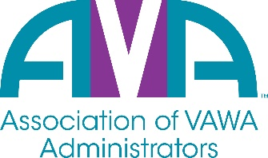
To encourage and facilitate mutual support, awareness, and cooperation
among states and territories administering Violence Against Women Act grants

OVW/AVA
Conference Call Agenda
Monday, January 10th, 2022
11:00am EST
- Welcome & Introductions
  - OVW – Amy Loder, Melissa Schmisek, Omar Mohammed, Zelda Tackey
  - AVA – Julia Fuller-Wilson, MaryEllen Garcia, Stephanie Lowery, Amy Baynes, Cecilia Miller, Gene Nelson, Nakia Harris, Barry Bryant
- Discussion

  - Implementation Plans – Any Updates?
    - Per 1/26/22 Memo from Amy Loder/OVW
“The Plan must be submitted in JustGrants with your FY 2022 STOP application. We anticipate posting the STOP solicitation on April 27, 2022, with an application deadline of June 14, 2022. The deadline was determined to allow for the maximum amount of time for states and territories to complete their Plans, while providing sufficient time for OVW to process FY 2022 STOP awards.”
    - “States and territories will not have access to FY 2022 STOP funds until their Plan has been reviewed and approved by OVW.”

  - Safe Stay Program within ReloShare company
    - Several VAWA Administrators have been contacted via email by asking if administrators would like for them to share their contact information with other providers in their state. This is what AVA knows about the agency and what OVW confirmed following our conference call:
      - Safe Stay provides services to non-profits and governmental agencies,
      - They find hotels that will allow customers to book anonymously or with an alias and do not always require a credit card.
      - Safe Stay does not contact the hotel on behalf of crime victim as advocates call instead
      - Safe Stay does not pay for rooms but does receive a small percentage of the cost of a night’s stay from the hotel.
      - They have a national database of hotels and sharing this information is the primary resource that they offer.
  - Plans for Virtual Conversations in 2022
    - AVA asked if OVW will be conducting virtual or in-person meetings in 2022 and OVW indicated at this time that they plan to only meet virtually in 2022.
    - They will share important meeting dates with administrators over the coming months.

- Adjourn – The meeting was adjourned at approximately 11:40 am EST. The next OVW/AVA meeting is scheduled for April 11th, 2022.

