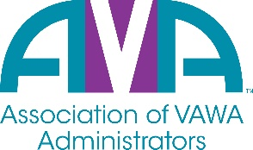

The mission of the **Association of VAWA Administrators (AVA)** is to encourage and facilitate mutual support, peer enrichment, awareness and collaboration among states and territories administering **STOP Violence Against Women Act (VAWA**) Formula Grant Programs.

**Membership Registration Form**

**July 1, 2025 - June 30, 2026**

Agency/Organization:

STOP Program ***Primary*** Contact:

Title/Position:

Address:

City, State, Zip

Phone

Email Address:

STOP Program ***Secondary*** Contact:

Title/Position:

Address:

City, State, Zip

Phone

Email Address

Other funds your agency administers as issued by OVW or other funders:

Please list below any additional staff that you would like to have added to the AVA Listserv.

|  |  |  |  |
| --- | --- | --- | --- |
| **Staff Name:** | **Title:** | **Email:** | **Phone Number:** |
|  |  |  |  |
|  |  |  |  |
|  |  |  |  |

If you have any questions or concerns, please contact Arlene Vassell, AVA Executive Director, or any of the AVA Board Members. Also, please mail registration forms and fees to:

**Arlene Vassell, Executive Director**

**Association of VAWA Administrators**

**6574 N. State Road 7, PMB 341  
Coconut Creek, FL 33073  
(954) 299-7648**  
 **Email:** [**avassell@avadministrators.org**](mailto:avassell@avadministrators.org)