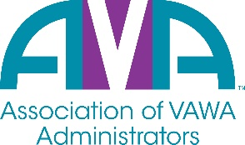
To encourage and facilitate mutual support, awareness, and cooperation among
states and territories administering Violence Against Women Act formula grants

Membership Registration Form
July 1, 2023 - June 30, 2024

Agency/Organization:

STOP Program Primary Contact:
Title/Position:
Address:
City, State, Zip
Phone
Email Address:

STOP Program Secondary Contact:
Title/Position:
Address:
City, State, Zip
Phone
Email Address

Other funds your agency administers as issued by OVW or other funders:

Please list below any additional staff that you would like to have added to the AVA Listserv.

Staff Name: | Title: | Email: | Phone Number:

If you have any questions or concerns, please contact Barry Bryant, AVA Executive Director, or any of the AVA Board Members. Also, please mail registration forms and fees to:

Barry Bryant, Executive Director
Association of VAWA Administrators
9660 Falls of Neuse Rd., Suite. 138, PMB 211
Raleigh, NC 27615
Phone: (919) 588-9615
Email: Barry@avadministrators.org

