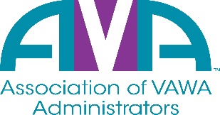

To encourage and facilitate mutual support, awareness and cooperation
among states and territories administering Violence Against Women Act grants.

2022 Election Questionnaire

Name of Candidate: Julia Fuller-Wilson

Title/Position of Candidate: Board Member

State Total number of years as a VAWA Administrator/staff: 9

Contact information:

State: Virginia
Agency: Department of Criminal Justice Services
Phone Number: (804) 371-0386
Email address: Julia.fuller-wilson@dcjs.virginia.gov

Please answer the questions below to provide information about your qualifications to other VAWA Administrators.
1. Briefly describe current VAWA responsibilities.
I am currently the State VAWA Administrator for Virginia. This position includes completing the annual performance reports, applying for the annual STOP grant, assisting with developing the implementation plan, and providing guidance and assistance to our VSTOP Coordinator.

2. Briefly describe other relevant experience or qualifications.
I have worked in the field of victim services, particularly violence against women, for over 25 years both providing direct services to victims and in an administration capacity. I have experience developing curriculums, training law enforcement, prosecutors, advocates, and other allied professionals, providing technical assistance, grant monitoring, and administering state and federal grant funding.

I also hold a Master’s Degree in Social Work with a concentration on policy and administration from Virginia Commonwealth University.

3. Brief statement of why you wish to be on the AVA Board of Directors.
I would like to serve as an AVA Board member to learn from and assist other VAWA Administrators in performing their administration duties. I am also very interested in the policy development and training on issues that focus on violence against women and the criminal justice system.

By checking this box, I declare my intention to be a candidate for the AVA Board of Directors and signify my agency is or will become an active member of AVA.

