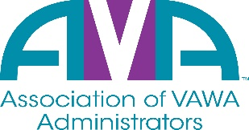

To encourage and facilitate mutual support, awareness, and cooperation
among states and territories administering Violence Against Women Act grants

Please complete and return to barry@avadministrators.org.

Name: _______________________________________________

State/Territory/D.C.: ________________________________________

Years of experience as a VAWA Administrator: _______________

