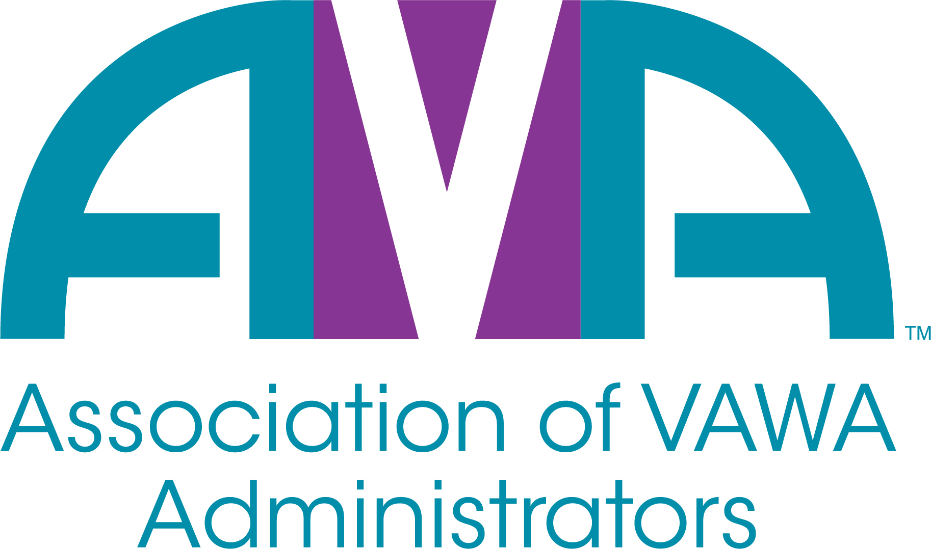

To encourage and facilitate mutual support, awareness and cooperation among
states and territories administering Violence Against Women Act formula grants.

AVA Annual Meeting Agenda
Tuesday, May 10th, 2022
1:30 PM – 3:00 PM EST
(Via Zoom)

1:30 pm Welcome & Introduction – Barry Bryant

1:45 – 2:10 pm Report from AVA President – Julia Fuller-Wilson (Virginia)
Report from AVA Treasurer – Cecilia Miller (Minnesota)
Update from AVA Executive Director – Barry Bryant

2:15 – 2:20 pm AVA FY 20-21 Board Nominees and Open Board Positions - Barry

2:25 – 2:45 pm Open Forum Discussion – MaryEllen Garcia (New Mexico)

2:50 – 3:00 pm Closing Remarks – Cecilia Miller

3:00 pm Adjourn

